1a.

A (0, 1, 0, 1)

B (1, 1, 1, 1)

C (1, 0, 1, 1)

D (0, 1, 1, 0)

E (1, 0, 0, 1)

Similarity between A and E

A.E = (0x1 + 1x0 + 0x0 + 1x1) = 1

||A|| =

||E|| =

Similarity between B and E

B.E = (1x1 + 1x0 + 1x0 + 1x1) = 2

||B|| =

||E|| =

Similarity between C and E

C.E = (1x1 + 0x0 + 1x0 + 1x1) = 2

||C|| =

||E|| =

Similarity between D and E

D.E = (0x1 + 1x0 + 1x0 + 0x1) = 0

||D|| =

||E|| =

1b.

Most similar – C

B

A

Least similar – D

1c.

If the system were to recommend an item for customer E it would be item 3. This is due to customer C being the closest to customer E and item 3 being the additional item purchased by customer C.

2a.

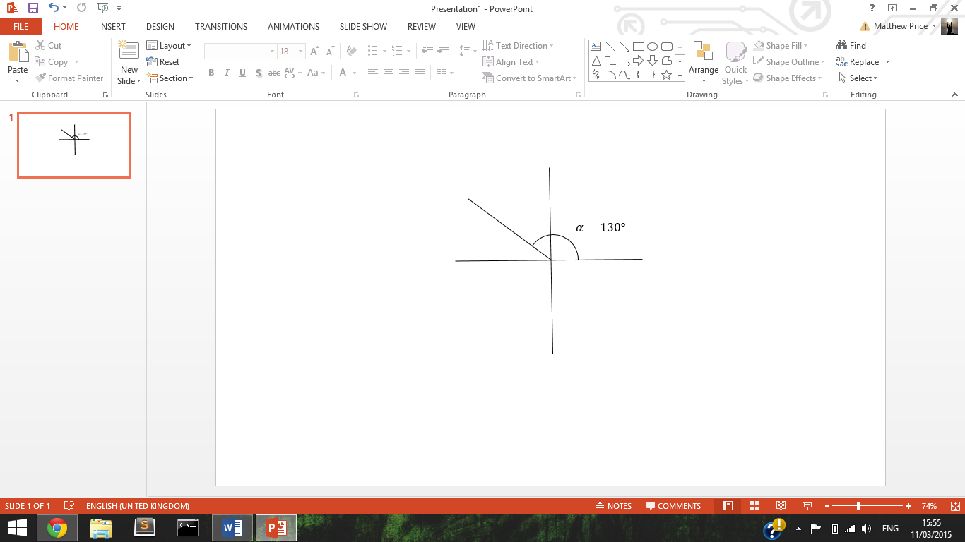

Reference angle $β=50°$

$$\sin{α}= \sin{β}= \sin{50}=0.77$$

$$\tan{α}= \tan{β= \tan{50=-1.19}}$$

2b.

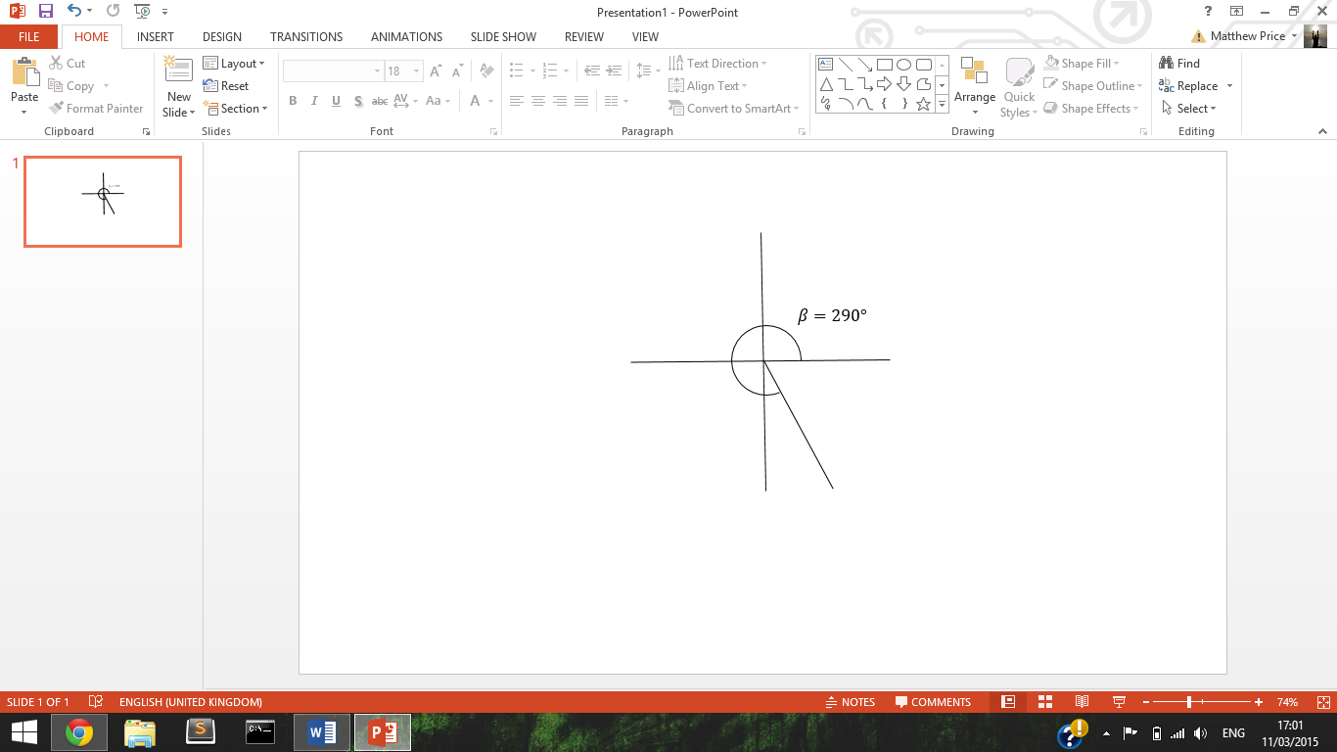

Reference angle $α=70°$

$$\sin{β= \sin{α=\sin{70=-0.94}}}$$

$$\cos{β= \cos{α= \cos{70=0.34}}}$$